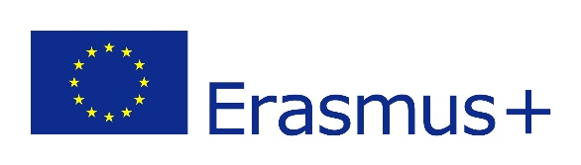 | 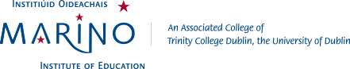

Student Mobility 2023/24

Marino Institute of Education is delighted to welcome students on Erasmus+ mobility in semester 1 and/ or semester 2 of the 2023/24 academic year.
Students can choose a bespoke 30 ECTS programme each semester from modules within or across the following three undergraduate programmes:
- B.Sc. in Early Childhood Education
- B.Sc. in Education Studies
- B.Ed. (Primary Teaching)
All modules are taught through the medium of English – with the exception of Irish language/ Gaeilge courses. Please note that module selection/availability is subject to timetabling requirements. A member of the Erasmus team will work individually with student to create their own personal timetable. Please see the following links for further information:

B.Sc. in Early Childhood Education
Access programme information here
Access information relating to modules, and see pages 12-15 for the breakdown of modules taught each semester in the programme handbook here

B.Sc. in Education Studies
Access programme information here
Access information relating to modules, and see pages 13-14 for the breakdown of modules taught each semester in the programme handbook here

B.Ed. (Primary teaching)
Access programme information here
Access information relating to modules and, see pages 19-31 for the breakdown of modules taught each semester in the programme handbook here

Further information
- For further information please contact erasmus@mie.ie
- Visit our website to learn more about Marino www.mie.ie

