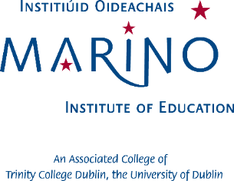
WEBSITE SCAVENGER HUNT

- What is one of the CAO code for the Bachelor in Education (English medium)?

- Name three MIE clubs and societies.

- What additional exam do students wishing to enter the Baitsiléir san Oideachas Trí Mheán na Gaeilge need to complete?

- Name the five categories of scholarships offered by Marino Institute of Education.

- What is the minimum maths entry requirements for the BSc in Early Childhood Education?

- Name three modules studied in the first year of the BSc in Education Studies.

Student name:
Student home address:

